Grant Grummer

2/15/2020

Dazzelite Assembly Instructions

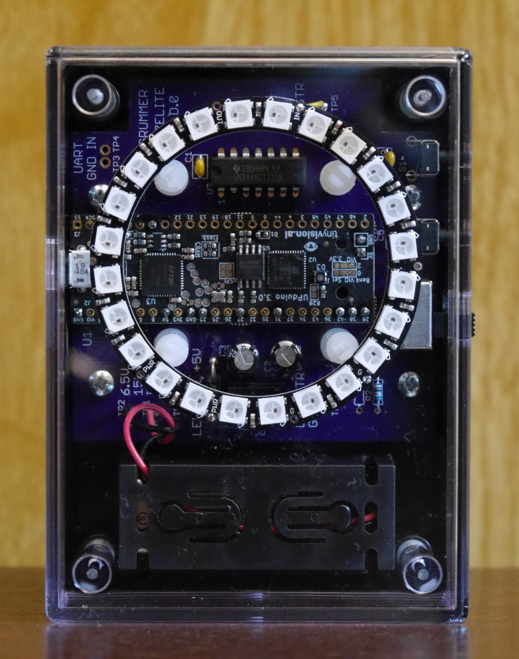

Revision: A.0

Table of Contents

Introduction 1

Tools required 1

PCB Assembly Instructions 1

Quick Instructions (for those who don’t like detailed instructions) 1

Detailed, Step by Step Instructions 2

Case Cutouts 2

Bottom (Opaque) Drilling and Cutouts 3

Top (Transparent) Case S2 and USB Cutouts 4

Connecting Battery Wires 5

# Introduction

These instructions cover how to build a Dazzelite using a custom PCB installed into a beautiful case. The case (listed in the DazzelitePL spreadsheet parts list) has a plastic transparent top and an opaque bottom. It is assumed that all the parts, listed in the Dazzelite parts list, have been acquired before starting this assembly process.

# Tools required

The following list of tools are needed to build a Dazzelite:

* Soldering iron
* Solder
* Drill
* 3/16” drill bit (an optional small ~3/32” bit is helpful for drilling a pilot hole first)
* Philips screwdriver, #1
* Masking tape (optional but highly recommended)
* Wire cutters/strippers
* Small pliers
* Hobby knife (like an X-Acto knife)

# PCB Assembly Instructions

Only through hole parts are used in Dazzelite in order to make the PCB assembly easy to do.

## Quick Instructions (for those who don’t like detailed instructions)

* Place a solder blob across the OSC solder jumper on the UPduino daughter board
* Remove D1 on the UPduino daughter board
* All components are soldered onto the component side of the PCB
* Insert the supports for the LED ring after all components have been soldered to the PCB
* Wires cut to 1-inch work well for connecting the LED ring to the PCB
* Do not attach the battery wires yet, it will be done in a later section

## Detailed, Step by Step Instructions

1. The UPduino board will need to be reworked before it can be used. It’s easier to do this rework before installing it onto the Dazzelite PCB. The rework involves the following two steps.
   1. Apply a blob of solder across the OSC solder jumper
   2. Highly recommend desolder and remove LED D1. It distracts from the ring display.
2. Apply a blob of solder across the OSC solder short on the UPduino board. Desolder D1.

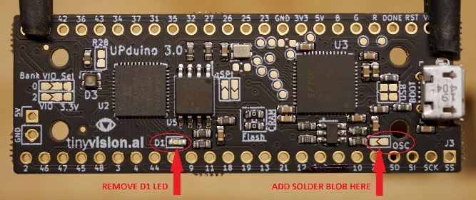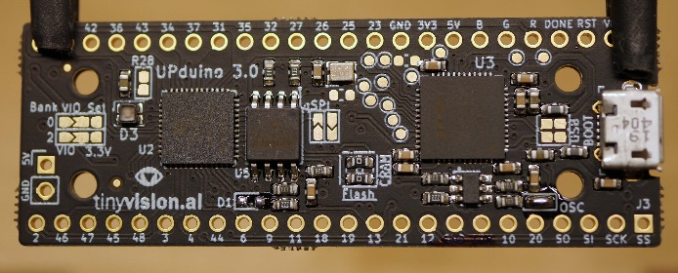

* Rotate the LED ring so that the “IN” and “OUT” holes on the ring align with edge of the PCB

# Case Cutouts

These instructions are from the prospective of the 9V battery part of case up and looking into the case. The cutout for the USB is on the right side and the cutouts for the switches are on the left side.

To avoid scratching the top (transparent) section, put masking tape on the outside of it. Cover the whole top and the top two thirds of the sides.

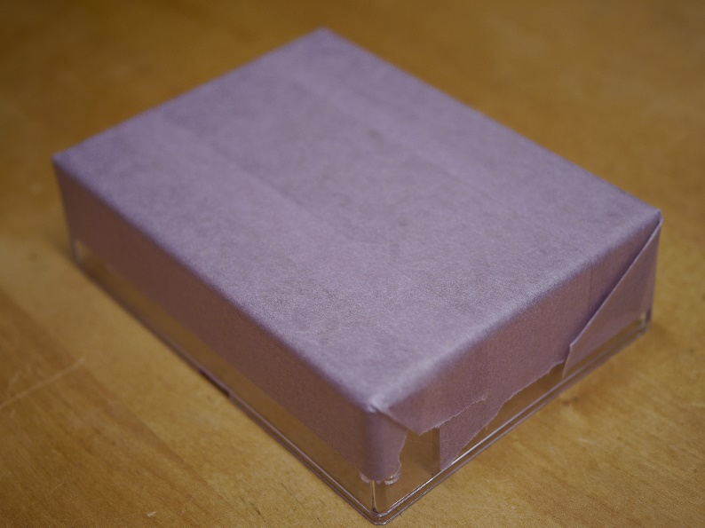

## Bottom (Opaque) Drilling and Cutouts

The top and bottom sections should not be attached.

All drill holes are located 5/8” from the bottom of the case.

The following table lists the locations of the drill holes from the side opposite the battery.

|  |  |  |
| --- | --- | --- |
| **Part** |  | **From Case Side Opposite Battery** |
|  |  |  |
| S1 PB SW Location | | 13/16 |
|  |  |  |
| S3 PB SW Location | | 1 & 7/16 |
|  |  |  |
| S2 Slide SW Location | | 1 & 15/16 and |
| 2 & 3/16 |
|  |  |  |
| USB Location | | 1 & 5/8 and |
| 1 & 13/16 |

Table 1: Drill Hole Locations

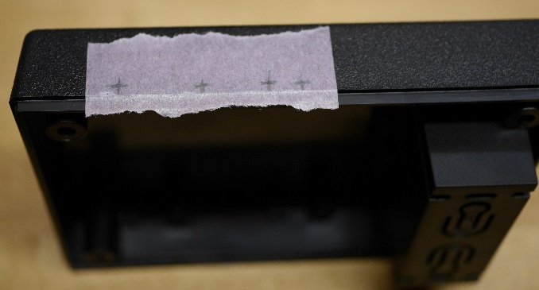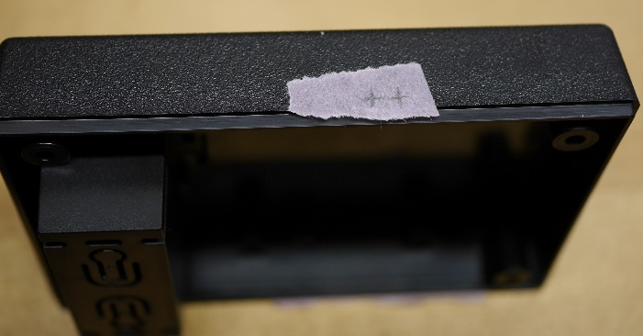

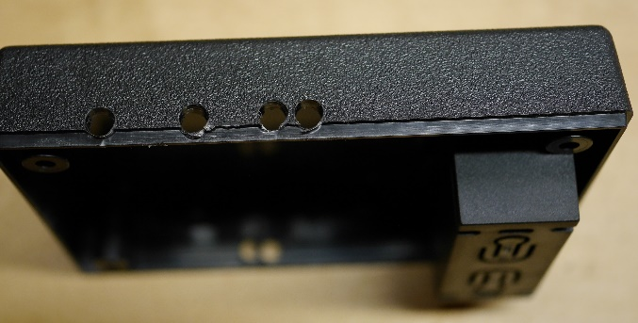

After the holes are drilled, make slots from the holes by cutting away the material from the side of the holes to the top on the bottom section of the case. Also cut away the material between the S2 (slide switch) holes and the USB holes.

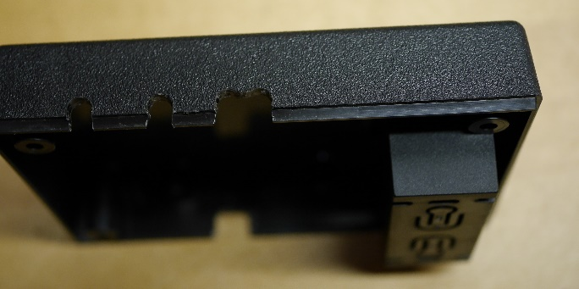

## Top (Transparent) Case S2 and USB Cutouts

Temporarily place the top and bottom sections together. The manufacturing plastic insertion dot side of the top section should align with the battery holder side of the case.

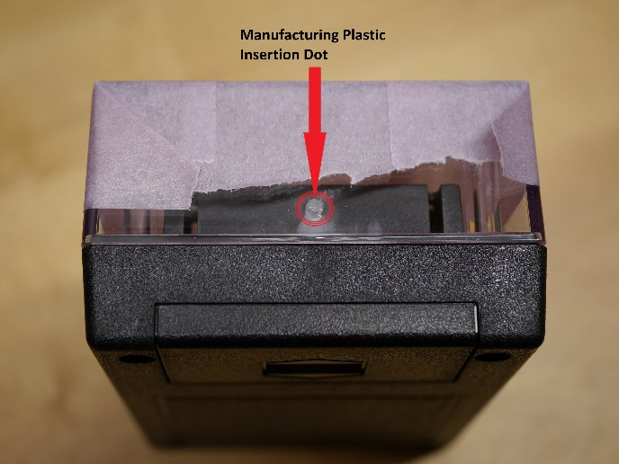

Mark (with the utility knife) where bottom section cutout for the S2 and USB cutouts meets the top section. There should now be 2 marks on each side. Separate the top and bottom sections. In each mark, cut down 0.1" to the thicker part of the top section. Cut away the thinner part (of the case) between the 2 marks on each side.

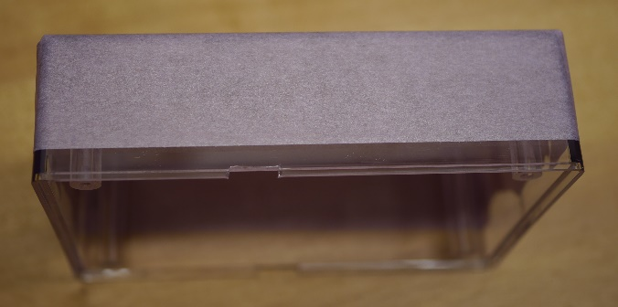

# Connecting Battery Wires

Temporary place the assembled PCB in the bottom section of the case. The battery wires go through the battery holder nearest to the “6.5V TO 15V INPUT” text on the PCB. The battery connector is placed at the opposite end of the battery holder.

Lift the assembled PCB so the battery wires can be soldered onto the board. The red (positive) wire connects to TP1 and the black (negative) wire connects to TP2.